USER REQUIREMENTS

The Bidder should provide the following in the specified order in Section 4 of the proposal/bid document.

Provide detail information of the proposed solution as per document enclosed. Please note that marking should be carried out in the following manner; The Remarks column should be used to explain or provide detail information.

DESCRIPTION | REMARKS
Rating - 5 | If the User requirement is met 100% as defined in the RFP without any work around method.
Rating - 4 | If the User requirement is met 75% as defined in the RFP without any work around method. Define the number of hours required for the modification and cost in US$ in the Remarks column, in order to provide 100% functionality as defined.
Rating - 3 | If the User requirement is met 50% as defined in the RFP without any work around method. Define the number of hours required for the modification and cost in US$ in the Remarks column, in order to provide 100% functionality as defined.
Rating - 2 | If the User requirement is met 25% as defined in the RFP without any work around method. Define the number of hours required for the modification and cost in US$ in the Remarks column, in order to provide 100% functionality as defined.
Rating - 1 | If the User requirement is met as a Work around method defined in the RFP. Define the number of hours required for the modification and cost in US$ in the Remarks column, in order to provide 100% functionality as defined.
Rating - 0 | If the User requirement is not met as a defined in the RFP and modifications are required. Define the number of hours required for the modification and costs in US$ in the Remarks column.

The NBL rating is as follows:
1 = critical; 2 = essential; 3 = nice to have

MOBILE BANKING
Mobile banking is supported by T24 ARC Mobile Banking. ARC Mobile Banking is offered to NDB Bank as an optional application and is not part of the standard proposal.
Ref : | User requirements | NBL Priority | Bidder’s Rating | Bidder’s Remarks
 | Security (Please provide details)
 | User Authentication | 1 | 5 | Supported by T24 ARC Mobile Banking.  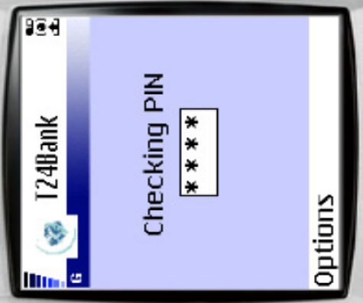  Figure 1. T24 ARC Mobile Banking
 | Secure communication (eg; SSL) | 1 | 5 | T24 supported
 | Comprehensive user id & password management including security policy settings | 1 | 5 | Supported by T24 ARC Mobile Banking.
 | Encryption & decryption | 1 | 5 | Supported by T24 ARC Mobile Banking.
 | Incomplete & Suspect transactions to diverted to a separate queue, routing to process/rejecting capabilities should be available with authorization and verification functions. | 1 | 5 | Supported by T24 ARC Mobile Banking.
 | Integration
 | Online integration with the Banking Systems as defined in the RFP. | 1 | 5 | Supported by T24 ARC Mobile Banking.
 | Online integration with third party & custom applications | 1 | 5 | Supported by T24. Temenos Open Connectivity Framework (TOCF) helps to achieve secured & seamless integration with third party systems (ATM, SMS…) to receive and react to generate all types of transactions/message
 | Features
 | Should enable personalized alerts via SMS/WAP (e.g.: for term deposits maturing in x days, Loan repayment due in X days, account overdrawn, rate changes) – user configurable | 1 | 3 | Supported through customization.
 | Cheque status inquiry | 1 | 4 | Supported through customization.
 | Balance Inquiry | 1 | 5 | Supported by T24 ARC Mobile Banking.  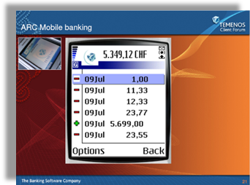  Figure 2. A/C Statement
 | Statement / Cheque Book request | 1 | 4 | Supported through customization.
 | Stop payments | 1 | 4 | Supported through customization.
 | Transaction management (stop unprocessed transaction instructions, place forward transaction instructions, view status) | 1 | 4 | Supported through customization.
 | Utility Bill payments | 1 | 4 | Supported through customization.
 | Mini Statement viewing | 1 | 5 | T24 ARC Mobile Banking supported to view account statement.
 | Multi currency Transactions | 1 | 5 | T24 is a multi-currency system by design and supports multiple currencies in terms of transactions, accounting.
 | Funds transfer between permitted accounts | 1 | 5 | Supported by T24 ARC Mobile Banking.  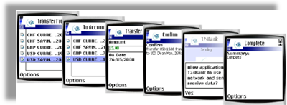  Figure 3. Inter-account Transfer
 | FX and Deposit rate inquiry | 1 | 4 | Supported through customization.
 | Technical Specifications
 | 24*7 uptime capability | 1 | 5 | Supported by T24.
 | Ability to automatically detect errors and fix them and send alerts to support staff. | 1 | 3 | Local enhancement required.
 | WAP & SMS capable | 1 | 5 | Supported by T24 ARC Mobile Banking.
 | Detailed description of how data integrity and recovery is maintained throughout the transaction. (How incomplete transactions are dealt with and if users are notified of successful transactions) | 1 | 3 | Supported through customization.
 | Transaction tracking and alerts for unsuccessful & suspect transactions (alerts to be sent to support staff (definable using routing tables)) | 1 | 3 | Supported through customization.
 | Automated backup & recovery functions. | 1 | 5 | Supported by T24.
 | Reports | 1
 | Transaction logging/reporting |  | 5 | Supported by T24.
 | Audit report for all changes to the system files and transactions to the system | 1 | 5 | Supported by T24.
 | Event journal with selective searches | 1 | 4 | T24 has similar enquiries/reports. We are assuming that the format of these enquiries and reports meet the requirements of NDB Bank. If not, then NDB Bank can use T24 Enquiry and Report designer tools to modify them.
 | Usage management Reports (what are the most frequently used features, who are the regular users) | 1 | 4 | T24 has similar enquiries/reports. We are assuming that the format of these enquiries and reports meet the requirements of NDB Bank. If not, then NDB Bank can use T24 Enquiry and Report designer tools to modify them.
 | Audit trail of all transactions performed, suspect transactions & rejected transactions | 1 | 4 | T24 has similar enquiries/reports. We are assuming that the format of these enquiries and reports meet the requirements of NDB Bank. If not, then NDB Bank can use T24 Enquiry and Report designer tools to modify them.

